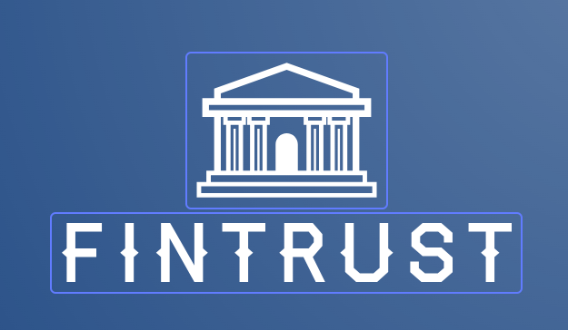 FinTrust Bank India

**BRD- Business Requirements Document**

**1. The Current Business Problem:** Currently, FinTrust Bank is providing in-branch services only. Customers need to visit the branch for banking purposes like registration, to check balance , transfer funds , request transaction details , etc which leads to high manual workload, poor customer experience, increased operational cost, long queues at branch, slower service and no-self service option. All these issues leads to customer switching to digital banks.

**2. The Proposed Solution:** We are offering online banking services to manage all customers efficiently by solving the current issues and thereby improving customer experience. Customer can manage their account 24/7 and there is no need of visiting the branch physically to solve any of their issues. It gives the customer better flexibility to handle their own account.

**3. System Impacted:** A new customer-facing online banking website will be developed and integrated with FinTrust's core banking and user authentication systems.

**4. Assumptions/Dependencies:** N/A

**5. Business Requirements:**

**5.1 Digital Profile Management**

5.1.1 Ability for users to register

5.1.2 Ability for user to login

5.1.3 Ability for user to set password

5.1.4 Ability for user to change password

**5.2 Dashboard Management**

5.2.1 Ability for user to view profile information

5.2.2 Ability for user to view current balance

5.2.3 Ability for user to account summary

5.2.4 Ability for user to view transactions done

**5.3 Account Management**

5.3.1 Ability for user to edit profile

5.3.2 Ability for user to view profile details

5.3.3 Ability for user to view account summary

5.3.4 Ability for user to view bank statements

5.3.5 Ability for user to view current balance

5.3.6 Ability for user to manage their banking details

**5.4 Funds Management**

5.4.1 Ability for user to transfer funds

5.4.2 Ability for user to view transaction history